**Lab 5: Forces on Submerged Objects**

1. **Background Information**

When an object is submerged in a fluid (liquid or gas), it will experience a force due to the pressure exerted by the fluid on the object. The amount of force depends on the density of the fluid and the depth to which the object is submerged. Understanding the amount of force exerted by a fluid on an object is very important, especially when designing hydraulic systems, submergible vehicles, or aircraft.

The problem with the forces felt by submerged objects does not lie directly with the force exerted by the liquid, but instead because of differences in pressure inside and outside of an object. When standing at sea level, a person is actually experiencing a pressure of 101300 N/m2 or 14.5 lbs/in2. This amount of force should easily crush you, but because of the way our bodies are designed, they push out with an equal amount of force. However, if you were to dive into a pool and swim down 33 feet (around 10m), you would double the amount of pressure your body is experiencing.

When a submarine travels underwater, it experiences a sizable pressure on the outer hull, but the pressure on the inner hull needs to be maintained at around sea level so that the human crew can survive. It is this difference in pressure that needs to be taken into account when designing the submarine, especially at weak points such as external doorways and hatches.

A similar problem is encountered by aircraft, except reversed. When an aircraft is flying at cruising altitude, the pressure outside the cabin is significantly lower than the pressure maintained inside the cabin to allow the passengers and crew to survive. This again causes a pressure difference which must be taken into account so that windows and doors don’t blow out. This is also partially responsible for the effect seen in movies when a door is opened on an aircraft and people get sucked out. It is the swift movement of the air inside the aircraft out through the newly opened passage attempting to equalize the pressure that throws people and objects out of the plane.

1. **Understand the Process**

The force that acts on a horizontal object with a surface area ***A*** at a depth of ***y*** in a liquid of density ***ρ*** can be calculated as:

Force = (Po + ρgy)*A

where Po is standard atmospheric pressure (101353 N/m2) and g is acceleration due to gravity (9.81 m/s2). The term (Po + ρgy) adjusts the pressure for the distance below the surface of the fluid due to the weight of the fluid above the object. However, if the object is vertical, or if the area of the object is not able to be calculated easily, a slight modification needs to be made to the equation above, as the pressure will differ from the top of the plate to the bottom. Assume we have the situation shown in figure 1 with an oddly shaped plate submerged in liquid. The top of the plate is a distance ***d*** below the surface of the liquid and has a height of ***h***, meaning that the bottom of the plate is a distance ***d+h*** below the surface of the liquid. Depending on the height of the plate, this can cause a noticeable difference in pressure from the top to the bottom of the plate.

**Figure 1: Plate Submerged in Liquid**



Since we no longer have a constant pressure and are not able to easily calculate the area of the plate, we need to find a new approach. What we can do is break this plate up into a bunch of very small shapes for which we can easily calculate the area (a rectangle, for instance). We can also assume that if these small sections of the plate are small enough, then the pressure for these sections is uniform. One such section is shown in green in figure 1. This section is a rectangle with a width of ***x*** (defined by the distance between the two curved sides of the plate), a height of ***dy***, and is at a distance ***y*** from the surface. Therefore, the force acting on this small section of plate can be calculated using the previous equation:

Area = x*dy

Force = (Po + ρgy)*(x*dy)

In order to find the total force acting on the plate, we need to sum all of these small sections together. If we have an infinite number of infinitely small sections, this requires the use of an integral. Therefore, our total force on the plate can be calculated as:

$$Total Force = \int_{d}^{d+h}{(P_{o} + ρgy)*x*dy}$$

If we try to estimate this integral using the Trapezoidal Rule, our equation would become:

$$Total Force=\sum{(P_{o} + ρgy)*\frac{\left(x_{1}+x_{2}\right)}{2}*dy}$$

In this lab, we will use this equation and our numerical integration methods to determine the total force acting on both a submarine hatch at different depths and an aircraft door at different altitudes.

1. **Submarine Hatch**

The first application we will explore is the hatch on a submarine. A picture of the type of hatch we are exploring is shown to the right. Follow the steps below to analyze the effects of depth and pressure on the design for the hatch.

1. Download the ***Submarine_Hatch.mat*** file on Blackboard. This file contains three vectors:
   * x_left: the x-coordinates of the left side of the hatch (in meters)
   * x_right: the x-coordinates of the right side of the hatch (in meters)
   * y_hatch: the y-coordinates of the hatch (in meters)
2. Create a new script file and include an appropriate header.
3. Add commands to load the data in the Submarine_Hatch.mat file into MATLAB.
4. Add commands to plot the outline of the hatch so you can get a better understanding of what the hatch looks like. For your plot, use the axis command:

axis([-1 1 -2 0])

***NOTE: in your plot, be sure to pay attention to where the origin is located and the dimensions for the door.***

**Plot of submarine hatch:**

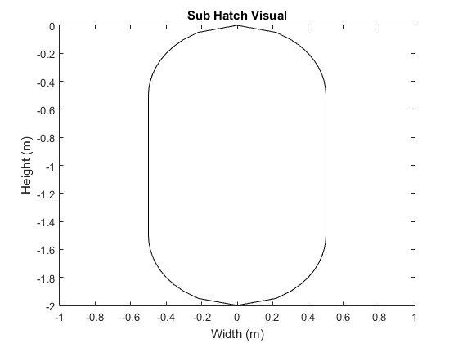

1. Add a command to your script to prompt the user for the current depth of the submarine. *Depth indicates how far* ***the top*** *of the submarine hatch is below the surface of the water.*
2. In order to help prepare you to determine the forces acting on the hatch, answer the questions below about applying the trapezoidal rule in this situation:

|  |  |  |  |  |
| --- | --- | --- | --- | --- |
| (0,0)  Depth, D  Surface  dy  P1  P2  P3  P4  X1  X2 | **What are the two widths of the trapezoid in terms of the x-coordinates of P1, P2, P3, and P4?** | | | |
| X1 = | P4x – P2x | |  |
| X2 = | P3x – P1x | |  |
|  | | | |
| **What are the X-coordinates of the four points in terms of the vectors from the data file (use index k for X1 and k-1 for X2)?** | | | |
| P1: | x_left(k-1) | |  |
| P2: | x_left(k) | |  |
| P3: | x_right(k-1) | |  |
| P4: | x_right(k) | |  |
|  | | | |
| **What is the value of dy?** | | | |
| dy = | y_hatch(k-1) – y_hatch(k) | |  |
|  | | | |
| **What is the depth of the trapezoid area (the depth of the top side of the trapezoid)?** | | | |
| Depth_Trap | | depth - y_hatch(k-1) |  |

1. Implement code to determine the overall force acting on the outside of the hatch due to the surrounding water. You should use the Trapezoid Rule to estimate the integral as shown in Part B. Assume the density of salt water is 1027 kg/m3.

***NOTE: you will need to use the coordinates provided in the data file in order to determine the left and right widths of your trapezoid. Be careful which coordinates you use to determine your widths!***

1. Implement code to determine the overall force acting on the inside of the hatch due to the air inside the submarine. Since the hatch is not submerged in this situation, the density term simply reduces to Po. Again, you should use the Trapezoidal Rule to estimate the integral.
2. Add code to your script that will display:
   * The force acting on the outside of the hatch
   * The force acting on the inside of the hatch
   * The net force acting on the door
   * Whether the submarine can reach the depth safely if the hatch has been rated to withstand a force of 5000000 N.
3. Use your script to complete the table below:

|  |  |  |  |  |
| --- | --- | --- | --- | --- |
| **Depth** | **Outside Force** | **Inside Force** | **Net Force on Hatch** | **Safe Depth?** |
| 150 m | 2881604 N | 1800161 N | 2701588 N | Yes |
| 250 m | 4671032 N | 1800161 N | 4491016 N | Yes |
| 350 m | 6460459 N | 1800161 N | 6280443 N | No |

**Paste your script file for submarine hatch here:**

%Part C

load Submarine_Hatch.mat;

figure(1)

plot(x_left,y_hatch,'k-',x_right,y_hatch,'k-');

axis([-1 1 -2 0]);

xlabel('Width (m)');

ylabel('Height (m)');

title('Sub Hatch Visual');

depth = input('Depth: ');

p = 1027; g = 9.81;

total_out = 0;

total_in = 0;

for k = 2:length(y_hatch)

total_out = total_out + (101353 + p*g*(depth - y_hatch(k-1)))*...

((x_right(k)-x_left(k))+(x_right(k-1)-...

x_left(k-1)))/2*(y_hatch(k-1)-y_hatch(k));

end

for k = 2:length(y_hatch)

total_in = total_in + 101353*...

((x_right(k)-x_left(k))+(x_right(k-1)-...

x_left(k-1)))/2*(y_hatch(k-1)-y_hatch(k));

end

netF = total_out - total_in;

if netF > 5000000

depth_safe = 'No';

else

depth_safe = 'Yes';

end

fprintf('Outside force: %i N\n',total_out);

fprintf('Inside force: %i N\n',total_in);

fprintf('Net force: %i N\n',netF);

fprintf('Can the sub reach this depth safely? %s\n',depth_safe);

1. 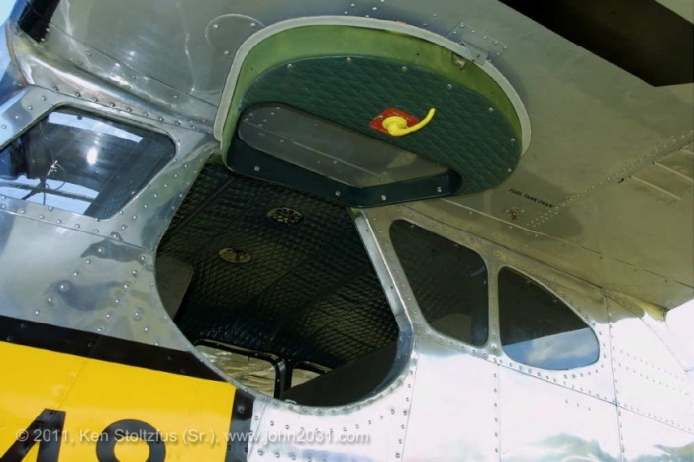**Aircraft Door**

Next, we will explore opposite case from part C, namely the hatch on an airplane flying at a given altitude. A picture of the type of hatch we are exploring is shown to the right, which is from a US Air Force LC-126C. Follow the steps below to analyze the effects of altitude and pressure on the design for the hatch.

1. Download the ***Airplane_Hatch.mat*** file on Blackboard. This file again contains three vectors:
   * x_left: the x-coordinates of the left side of the hatch (in meters)
   * x_right: the x-coordinates of the right side of the hatch (in meters)
   * y_hatch: the y-coordinates of the hatch (in meters)
2. You will be able to reuse most of your code for this section, with a couple of slight modifications:
   * Change your input statement to ask the user for the current altitude of the aircraft. *Altitude is how far* ***the bottom*** *of the airplane hatch is above the ground.*
   * Adjust your code for computing the outside pressure to use the following expression in place of the (Po + ρgy) term:

P = Po*(1 - 2.25577⬝10-5*h)**5.25588**

* P - Air pressure (N/m2)
* h - Altitude (meters)
  + Update your output section to display the exterior and interior pressure at the given altitude and to check to see whether the hatch will be able to withstand the altitude if it is rated to withstand a force of 350000 N.

1. Use your script to complete the table below:

|  |  |  |  |  |  |
| --- | --- | --- | --- | --- | --- |
| **Altitude** | **Exterior Pressure** | **Outside Force** | **Inside Force** | **Net Force on Hatch** | **Safe Altitude?** |
| 2500 m | 74703 N/m2 | 515119 N | 698884 N | 183765 N | Yes |
| 5000 m | 54034 N/m2 | 372599 N | 698884 N | 326284 N | Yes |
| 6000 m | 47194 N/m2 | 325428 N | 698884 N | 373455 N | No |

**Paste your script file for aircraft door here:**

%Part D

load Airplane_Hatch.mat;

h = input('Altitude: ');

g = 9.81;

total_out = 0;

total_in = 0;

p_ext = 101353*(1-.0000225577*h)^5.25588;

for k = 2:length(y_hatch)

total_out = total_out + p_ext*...

((x_right(k)-x_left(k))+(x_right(k-1)-...

x_left(k-1)))/2*(y_hatch(k-1)-y_hatch(k));

end

for k = 2:length(y_hatch)

total_in = total_in + 101353*...

((x_right(k)-x_left(k))+(x_right(k-1)-...

x_left(k-1)))/2*(y_hatch(k-1)-y_hatch(k));

end

netF = total_in - total_out;

if netF > 350000

altitude_safe = 'No';

else

altitude_safe = 'Yes';

end

fprintf('Exterior pressure: %i (N/m^2)\n',p_ext);

fprintf('Outside force: %i N\n',total_out);

fprintf('Inside force: %i N\n',total_in);

fprintf('Net force: %i N\n',netF);

fprintf('Can the sub reach this altitude safely? %s\n',altitude_safe);

1. **To be turned in:**

You will need to upload this word document with all requested tables, questions, and figures included and the m-files for your final script.